WINTER PARK HIGH SCHOOL BANDS

Thursday, December 10, 2015 | 7:00 PM
Winter Park High School | Ann Derflinger Auditorium

Freshman Jazz Band
Christopher Blackmer, director

Minor Attitude (2004) Dean Sorenson
(b. 1963)

Stormy Weather (1933/1989) Harold Arlen & Ted Koehler
arr. Jerry Nowak
Anyae Reed, vocalist

Jazz Ensemble I
Michael Clemente, director

The Nutcracker Suite (1978/2010) Peter Ilyich Tchaikovsky
(1840-1893)
arr. Billy Strayhorn and Duke Ellington
ed. Jeff Lindberg
- Overture
- Toot Toot Tootie Toot
- Peanut Brittle Brigade
- Sugar Rum Cherry
- Entr’acte
- Volga Vouty
- Chinoserie
- Dance of the Floreadores

Concert Band
Christopher Blackmer, conductor

The Royal Irish Regiment (2015) Larry Clark
(b. 1963)

Variants on a Shaped Note Tune (2006) Johnnie Vinson
(b. 1943)

Symphonic Band
Michael Clemente, conductor

Undecim: “Eleventh Hour” (2015) Randall D. Standridge
(b. 1976)

Whispers (2007) Sandy Feldstein and Larry Clark
(1940-2007/b. 1963)

Gaudete (2015) 16th Century Carol
arr. Brian Beck

In the Forest of the King: “A Suite of Old French Folksongs” (2000) Pierre LaPlante
(b. 1943)

Wind Ensemble
Christopher Blackmer, conductor

Who’s Who in Navy Blue (1920/1995) John Philip Sousa
(1854 – 1932)
ed. Frank Byrne

Contrapunctus V (c.1751/2013) Johann Sebastian Bach
(1685 – 1750)
arr. Larry Daehn

Minor Alterations No. 2: “Carols from the Dark Side” (2010/2013) David Lovrien
(b. 1973)
Michael Clemente, conductor

Sleigh Ride (1948) Leroy Anderson
(1908 – 1975)

CONCERT ETIQUETTE

- Make certain that all cellphones are either turned off or muted prior to the start of the performance.

- Parents should keep small children seated with them. If children become restless or fussy, please move them to the auditorium lobby.

- Clapping is the appropriate way to show appreciation for the performance rather than whistling or cheering.

- Watch the conductor when the music stops to decide whether to applaud. Some musical works have several parts or movements and the audience is expected to applaud only have all movements have been performed.

- Never stand or move around while music is being performed. It distracts listeners around you, as well as the performers on stage. If you must leave for any reason, please wait until a piece is finished, and the audience is applauding. Also, return to your seat only between pieces.

- Those video recording the performance with cameras or other electronic devices (including smart phones and tablets) should do so from the back of the auditorium.

- It is impolite to talk, or even whisper, while the music is being performed. Listeners and performers are also distracted by sounds from programs, candy wrappers, and other objects. Remain still, and be thoughtful of others by talking or making sounds only between pieces.

- It is impolite to wear hats or caps during a concert.

- It is impolite to eat or drink refreshments during a concert.

- Finally, please limit flash photography to those times in between pieces of music. Flashes emanating from a darkened auditorium can be extremely distracting to performers on stage.
PROGRAM NOTES

The Royal Irish Regiment – Larry Clark
The Royal Irish Regiment was commissioned by the Mulrennan Middle School Wind Symphony (Valrico, Florida), conducted by Michael Vail, and is dedicated to Mr. Vail’s son, Andrew. The Royal Irish Regiment is an infantry regiment of the British army, and Mulrennan is a surname of Irish descent. The work is written to emulate the sound of a classic British march – regal and majestic.

Variants on a Shaped Note Tune – Johnnie Vinson
Sacred Harp singing is the largest surviving branch of traditional American Shape Note Singing. “Sacred Harp” refers to The Sacred Harp, a book first published in 1844 and continuously updated since. The book used a system of printed shapes, instead of standard music notation, to help untrained singers learn to read the music. Along with other hymn books from the era, its repertoire of 550 four-part songs is part of the foundation of a singing tradition handed down since Colonial times and still practiced at numerous annual singing meetings and conventions and in local singing groups in the south and throughout the country.
Variants on a Shaped Note Tune is based on “Pisgah” which is number 58 in the Sacred Harp songbook. It is also sometimes known as “When I Can Read My Title Clear” and is believed to be on Scottish origin and first published around 1817.

Undecim: Eleventh Hour – Randall D. Standridge
John Schultz attended high school with the composer in Sheridan, Arkansas. They have maintained their friendship over the years, and Mr. Shultz has frequently asked Mr. Standridge to write pieces for his band, often at the last minute.

In the spring of 2014, John called to request an opening piece for their upcoming concert which was two weeks away. The composer, always up for a challenge, completed the piece in two days and Undecim was the result.

“Undecim” is Latin for “eleven,” referring both to the “eleventh hour” (the last opportunity to get something done) and to the opening metric feel of the piece (7/8 + 2/4 = 11 eighth notes).

Whispers – Sandy Feldstein & Larry Clark
The composer, Larry Clark, writes, “Whispers is a special composition for me. It was written together with Sandy Feldstein, but it is dedicated to him for all the great things he has done for me personally and for all he has done for music education during his illustrious career. It is a heartfelt composition in a lyrical style. Beautiful melodies are given numerous orchestrational and harmonic treatments to create a musical journey that will be pleasing to performers and audiences.”

Gaudete – 16th Century Carol/arr. Brian Beck
Gaudete dates back to the 16th century and was sung as a Christmas carol throughout the monasteries of Europe. Meaning “rejoice” in Latin, this piece captures the intense passion of praise coupled with moments of calm reverence.

In the Forest of the King – Pierre LaPlante
In the Forest of the King (originally titled Trois Chansons Populaires) is a three movement suite of contrasting movements based on traditional French folksongs. “Le Furet” (the ferret) is an old children’s song that can be used in a circle game. A ring on a string is passed around while a child in the middle tries to guess where it is.

“The Laurel Grove” has existed in many variants for hundreds of years and has appealed to both children and adults, but at different levels of understanding and interpretation. The tune in this version was very popular during the 18th century, especially at the Court of Versailles.

The setting opens and closes in a quiet manner suggesting a time and a place that now only exists in one’s memory. “King Dagobert” may have been a medieval troubadour’s ditty poking fun at royalty. Trumpets and drums announce the arrival of King Dagobert and his entourage as they prepare for the hunt.

Who’s Who in Navy Blue – John Philip Sousa/ed. Frank Byrne
Sousa composed Who’s Who in Navy Blue as a result of a request from Midshipman W.A. Ingram, president of the Class of 1920 at the U.S. Naval Academy in Annapolis, Maryland. It had become a custom for each graduating class to have a new song composed for graduation and the Class of 1920 chose the “March King.” Sousa had served in the Navy himself during World War I, and this no doubt played a large part in their decision.
Sousa dedicated the march to Tecumseh, the famous Native American statue that stands outside Bancroft Hall at the Naval Academy. Sousa also composed words to the melody of the trio, which read: “The moon is shining on the rippling waves, The stars are twinkling in the evening sky, And in our dreams Tecumseh softly tells us we’ll be Admirals by and by.”

Contrapunctus V – Johann Sebastian Bach/arr. Larry Daehn
The Art of the Fugue lay unfinished at the time of J.S. Bach’s death in 1750 as the last fugue was not quite complete. The collection of 14 fugues and 4 canons were all based on a single melodic idea (or subject), with each variation increasing in complexity and close imitation.

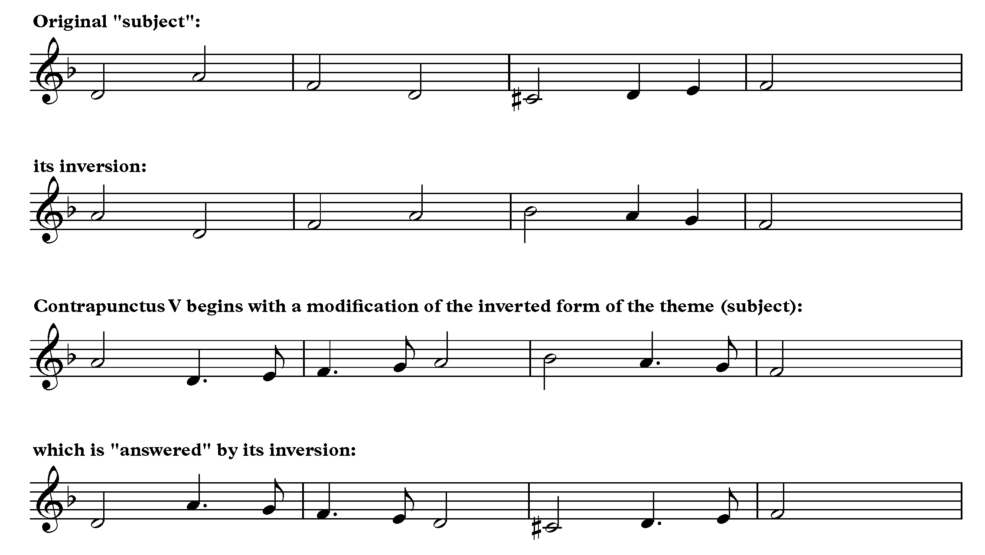

Minor Alterations No. 2 – David Lovrien
In this sequel to Minor Alterations: Christmas through the Looking Glass, David Lovrien takes a new set of familiar holiday melodies and twists them, distorts them, transposes them from major to minor, and finally sets them in the styles of famous minor-keyed orchestral pieces. Your idea of “O Holy Night” will never be the same when it’s set against Richard Wagner’s “Ride of the Valkyries.” If you aren’t able to feel the holiday spirit from this piece, I find your lack of cheer disturbing.

Sleigh Ride – Leroy Anderson
Sleigh Ride was written by Leroy Anderson during a heat wave in the summer of 1946. Although it was originally conceived as an instrumental work, lyrics were written to the piece by Mitchell Parish in 1950. According to Leroy Anderson’s biographer, Sleigh Ride has been performed and recorded by a wider array of performers than any other piece in the history of music.

UPCOMING EVENTS

Winterfest
Tuesday, December 15, Ann Derflinger Auditorium, 7:00 PM

Florida All-State Band & Orchestra
Thursday, January 14 – Saturday, January 16, Tampa Convention Center

Band Lock-In
Friday, January 22, 600 Building, 7:00 PM – 2:00 AM

FFCC Winter Guard Premiere Show
Saturday, January 23

All-County Band
Tuesday, January 26 – Saturday, January 30

Door-2-Door Fundraiser
Saturday, February 6, 8:00 AM – 5:00 PM

District Jazz MPA
Thursday, February 11, Apopka High School

District Solo & Ensemble MPA
Friday, February 12 & Saturday, February 13, Apopka High School

Orchestra Pre-MPA Concert
Wednesday, February 17, Ann Derflinger Auditorium, 7:00 PM

Guest Conductor Workshop
Thursday, February 18 – Saturday, February 20

Band Pre-MPA Concert
Saturday, February 20, Ann Derflinger Auditorium, 4:00 PM

