WINTER PARK HIGH SCHOOL BANDS
Thursday, December 8, 2016 | 7:00 PM
Winter Park High School | Ann Derflinger Auditorium

PROGRAM

Freshman Jazz Band
Christopher Blackmer, conductor

The Big Band Theory (2015) Larry Neeck

Pretty Eyes (2004) Dean Sorenson

After You’ve Gone (2012) Turner Layton
arr. Rich Sigler

Jazz Ensemble I
Michael Clemente, conductor

Something for Ernie (Nothing for Bert) (1996) Fred Stride

Hark! The Herald Angels Sing (2012) Traditional
arr. Gordon Goodwin

Humanism (2015/2016) Jonathan M. Batiste
arr. Paul Murtha

Concert Band
Christopher Blackmer, conductor

Normal (1923/2015) Harold Bennett
arr. Larry Clark

Olde English Carol (2016) Robert W. Smith

Sub-Saharan Rhythm (1998) David R. Gillingham

Symphonic Band
Michael Clemente, conductor

Melodious Thunk (2012) David Biedenbender
Christopher Blackmer, conductor

A Winter’s Carol (1996) Traditional
arr. Mark Williams

Brazilian Bell Carol (2016) Robert W. Smith

Wind Ensemble
Christopher Blackmer, conductor

Festival Fanfare for Christmas (1996/2014) John Wasson
Michael Clemente, conductor

The Eighth Candle (1997) Steve Reisteter

Fantasia in G (1982) Timothy Mahr

Please join us in the Auditorium lobby for refreshments following tonight’s performance!

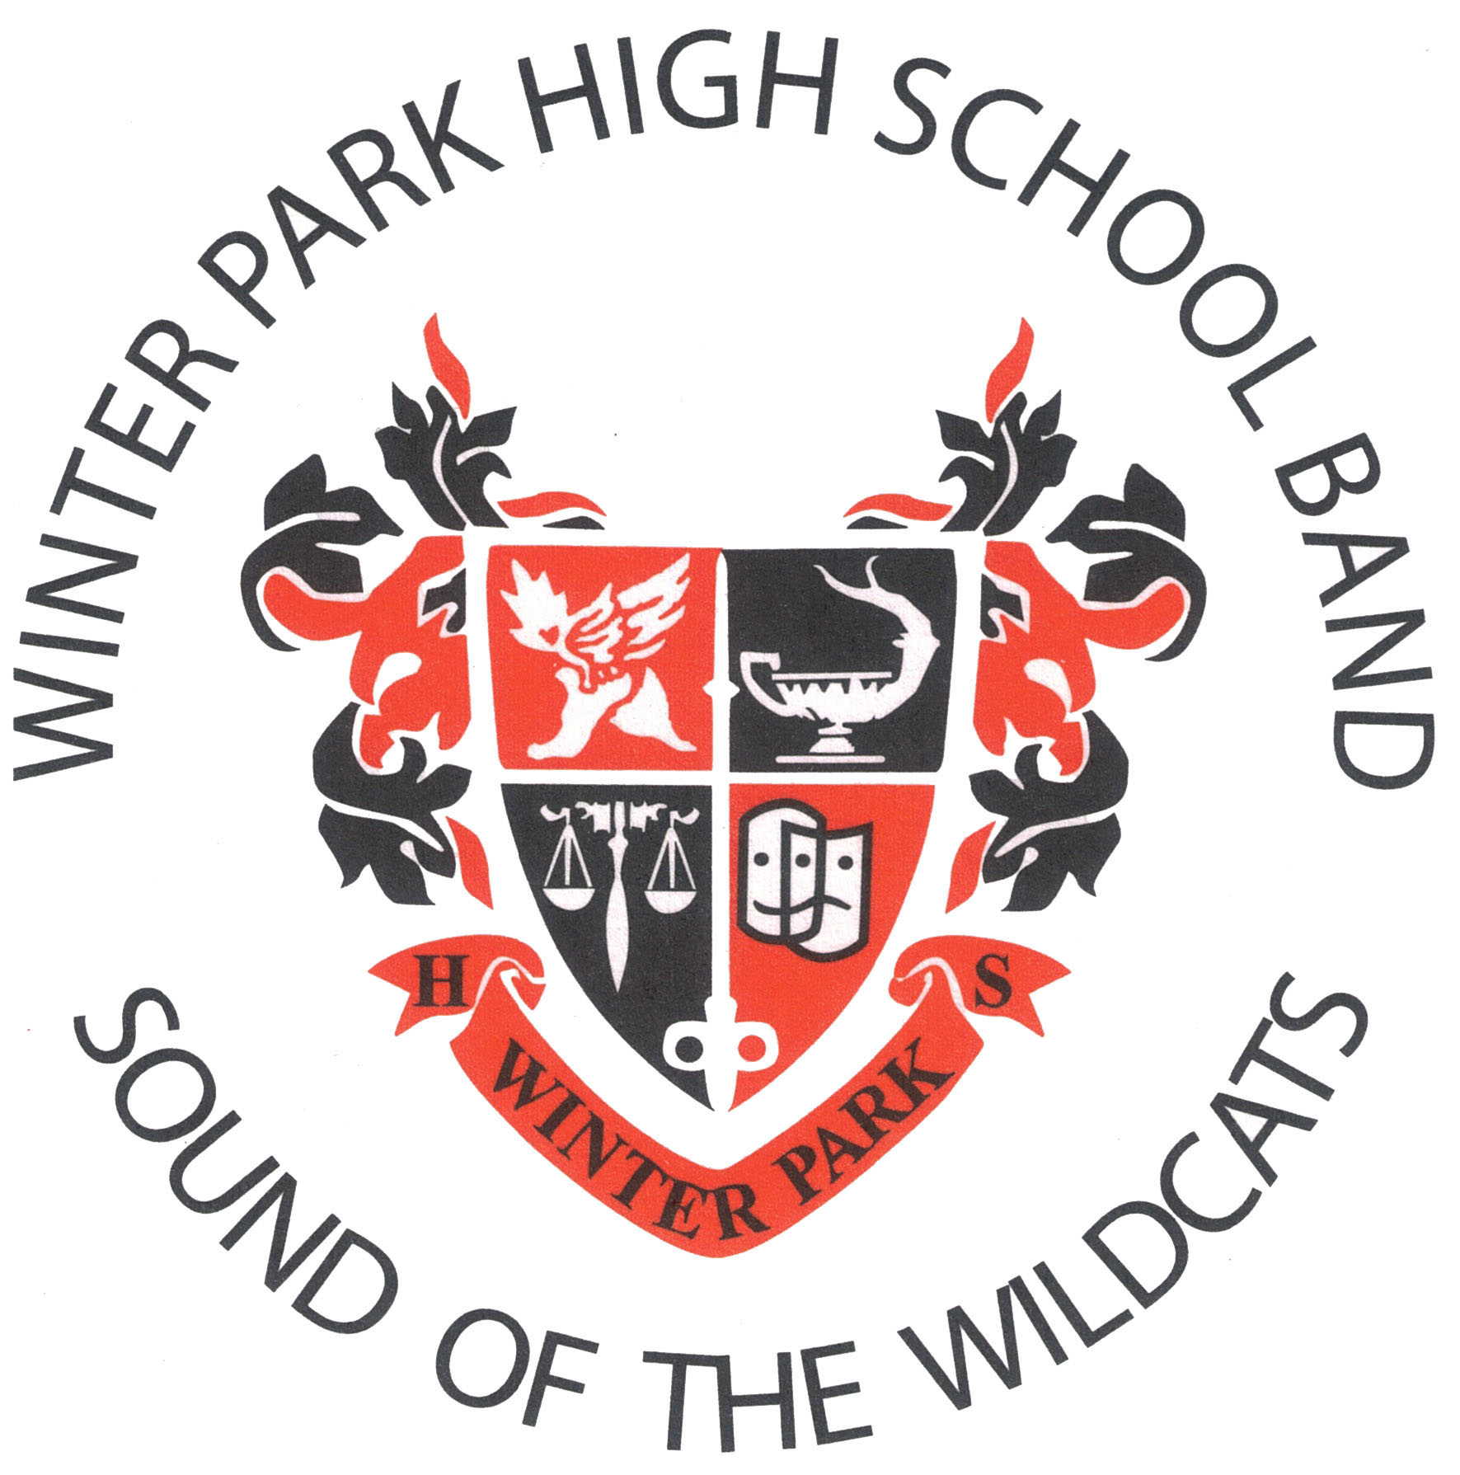

Congratulations to the following Winter Park Band students who successfully auditioned into the
Florida All-State Band or All-State Orchestra…
Nicholas Bulynin | Tommy Claus | Adam DeLoach | Samuel Dufresne |
Wade McCrea | Zachary Noble | Arvind Shankar

Congratulations to the following Winter Park Band students who successfully auditioned into the
All-County Band…
Shay Baker | Neftali Bernard | Gabriel Bornstein | Nicholas Bulynin | Alex Carpenter |
Tommy Claus | Mauricio Dantas | Adam DeLoach | Patrick DeLoach | Shira Diamond |
Samuel Dufresne | Jeremy Fielder | Jordan Gidus | Parker Goodwin | Corinne Guido | Evan Jackson | David Johnston | Edun Kalmar | Matthew Kuczajda | Eli Maulfair | Wade McCrea |
Zachary Noble | Tony Paredes | Madhav Patil | Maia Ruiz | Arvind Shankar | Tyler Stephens | Daniel Sullivan | Carly Thomas | Stuart Thomas | Colin Urbina | Sam Yarbrough

Congratulations to the following Winter Park Band students who successfully auditioned into the
All-County Jazz Band…
Tommy Claus | Adam DeLoach | Patrick DeLoach | Jordan Gidus | Evan Jackson | Edun Kalmar | Zachary Noble | Colin Urbina

PROGRAM NOTES
Normal
Normal by Harold Bennett (aka Henry Fillmore) was originally published in the popular Bennett Band Book, and it has become a forgotten gem among the many other Bennett marches. Fillmore wrote over 250 pieces and did orchestrations for hundreds more. He published under a variety of pseudonyms, including Gus Beans, Harold Bennett, Ray Hall, Harry Hartley, Al Hayes, and even Henrietta Moore – all based on the perceived “marketability” or style of the given work.

Olde English Carol
“What Child Is This?” is an old English carol from around 1865 by William Chatterton Dix. He set the beautiful and poignant lyrics to the English folk song known as “Greensleeves” which dates back to the late 16th century. Although composed in England, the melody is more popular in the United States than its country of origin.

Sub-Saharan Rhythm
David Gillingham writes, “Sub-Saharan Rhythm attempts to capture the spirit and emotion of the music of the sub-Saharan countries of Africa by incorporating three folk songs that are indigenous to this region: “Maiwe,” “wateh eh” and a “Liberation Song” which I acquired from a documentary film on Mbira and African music.”

Melodious Thunk
The composer writes: “Melodious Thunk was inspired by the famous jazz pianist Thelonious Monk. Monk’s wife, Nellie Smith, nicknamed him “Melodious Thunk” because of his clunky, awkward, and brilliant piano playing, and his somewhat scatterbrained and disoriented nature. I really liked the idea of playing around with Monk’s name – first, because I personally enjoy goofing around with “spoonerisms” (silly, ridiculous, mix-and-match letter games, which often happen by accident: for example, slip of the tongue becomes tip of the slung), and second, because this nickname actually provided great musical inspiration. Melodious – well, that’s fairly obvious – and thunk (which is great onomatopoeia!) became the starting points for this piece. Big, fat thunks are interspersed with pointy, clunky, bluesy blips, which are then transformed into long, smooth, laid-back melody accompanied by a funky bass line. I haven’t consciously borrowed any specific tunes or licks from Monk, although I do use a small fragment of Dizzy Gillespie’s tune Salt Peanuts, but I hope you’ll hear some similarities between this piece and Monk’s iconic musical style and quirky attitude.”

A Winter’s Carol
This unique treatment of the Latin carol “O Come, O Come, Emmanuel” uses the rich colors of the concert band to create an exquisite miniature tone poem. After a first atmospheric, then brooding introduction, the theme is introduced by the trombones. The theme is ominous, reminiscent of Gregorian chant. The mood changes with the theme highlighted by different voices in the ensemble, leading to a broad peak with fanfare interjections by the trumpets. Finally, a return to the introduction brings this work to its serene conclusion.

Brazilian Bell Carol
Featuring the percussion section, Brazilian Bell Carol is an exciting arrangement of the traditional Ukranian Bell Carol. Beginning with percussion grooves and solo fragments, the arrangement quickly transforms into the traditional bell carol in very untraditional setting. This bell carol is a Brazilian street parade accompanied by a complete samba school.

Robert W. Smith is one of the most prolific composers in America today. He has over 600 publications currently in print. Mr. Smith teaches in the Music Industry program at Troy University in Troy, Alabama.

Festival Fanfare for Christmas
Festival Fanfare for Christmas was commissioned and premiered by the Dallas Symphony Orchestra in 1996. The composer adapted the work for wind ensemble and it was subsequently performed by the Dallas Wind Symphony in 2012.

The composer was originally asked to create a work based upon two well-known Christmas carols, “Joy to the World” and “O, Come, All Ye Faithful,” and to utilize the four trumpets in the orchestra antiphonally from the balconies. The opening baroque-like fanfare originates in one pair of trumpets, moves to the horn section and then to the other pair of trumpets, and finally to the large ensemble.

John Wasson is a composer, arranger, producer, and church musician. He has been commissioned to write many original works and arrangements for such notable musical ensembles as the Dallas Symphony Orchestra, the United State Air Force Airmen of Note, and the Dallas Brass.

The Eighth Candle
Alluding to the story of Hanukkah and the victory of the Maccabees over the Syrian-Greek tyrant Antiochus over two-thousand years ago, The Eighth Candle begins with an extended hymn-like section, followed by an exciting dance of celebration. Legend has it that after the battles were won, there was only enough oil for the ceremonial lights to last for one day, yet, by some miracle, the oil lasted for eight days. Hanukkah is celebrated by the family in the home, rather than in the synagogue. In modern times, candles are lit, one for each day of the holiday, prayers are recited, followed by a feast and celebration.

Steve Reisteter is a contemporary American musician and composer from Pennsylvania.

Fantasia in G
Fantasia in G was composed in 1982 for the St. Olaf College Band and was premiered by that ensemble under the direction of the composer in January 1983. The piece was inspired by the first line of Friedrich Schiller’s poem “An die Freude,” freude, schoner gotterfunken (joy, bright spark of divinity), and the melody from Ludwig von Beethoven’s Ninth Symphony which provides the basic melodic material for the Fantasia. The work originated as an organ recessional for his brother’s wedding, and Mahr has stated that the work was intended to “get people out of church.”

Fantasia in G draws upon the spirit of both Schiller and Beethoven. While not Romantic in its compositional style, it is a tonal composition that captures the concept of the joyous “bright spark” using the simple yet powerful melody of Beethoven. This work also carries on a long tradition in wind band music of using the percussion as an integral part of the composition, providing not only color and rhythmic vitality, but also motivic material.

Timothy Mahr is an Associate Professor of Music at St. Olaf College in Northfield, Minnesota, where he also conducts the St. Olaf College Band. In addition, he teaches courses in composition, conducting, and music education. Mahr has over forty works to his credit, twenty-four of which were written for wind band.
UPCOMING EVENTS

Baldwin Park Holiday Parade
Saturday, December 10, 2016, 6 PM

FMEA All-State Band & Orchestra
Thursday, January 12, 2017 – Saturday, January 14, 2017

Band Lock-In
Friday, January 20, 2017, 6 PM – 2 AM

All-County Band
Tuesday, January 24, 2017 – Saturday, January 28, 2017

St. Olaf College Band Concert
Monday, January 30, 2017, 7 PM

Band Pre-MPA Concert
Saturday, February 18, 2017, 6 PM

Orchestra Pre-MPA Concert
Wednesday, February 22, 2017, 7 PM

Concert MPA (Symphonic Band)
Thursday, March 2, 2017, TBD

Concert MPA (Concert Band / Wind Ensemble)
Friday, March 3, 2017, TBD

For all Winter Park High School Band related information and events, go to
www.WinterParkHSBand.com

